
МИНИСТЕРСТВО НАУКИ И ВЫСШЕГО ОБРАЗОВАНИЯ РОССИЙСКОЙ ФЕДЕРАЦИИ
ФЕДЕРАЛЬНОЕ ГОСУДАРСТВЕННОЕ БЮДЖЕТНОЕ ОБРАЗОВАТЕЛЬНОЕ УЧРЕЖДЕНИЕ ВЫСШЕГО ОБРАЗОВАНИЯ
«ДОНСКОЙ ГОСУДАРСТВЕННЫЙ ТЕХНИЧЕСКИЙ УНИВЕРСИТЕТ» (ДГТУ)
Факультет «Информатика и вычислительная техника»
Кафедра «Кибербезопасность информационных систем»

Лабораторная работа №6
по дисциплине «Методы алгебраической геометрии в криптографии»
по теме: «Порядок точки эллиптической кривой»

Выполнил: обучающийся гр. ВКБ 43
Ковалев Д. П.

Проверил: старший преподаватель
Артамонова Е. А.

Ростов-на-Дону
2026

Цель: научиться находить порядок точки эллиптической кривой.
Ход работы:
Задание 1. На эллиптической кривой 𝐸𝑝(𝑎;𝑏), полученной в лабораторной работе №4, выбрать точку 𝑃 и определить её порядок. Написать программу, реализующую алгоритм поиска порядка точки эллиптической кривой над конечным полем.
Для запуска программы используется команда, которая представлена на рисунке 1.
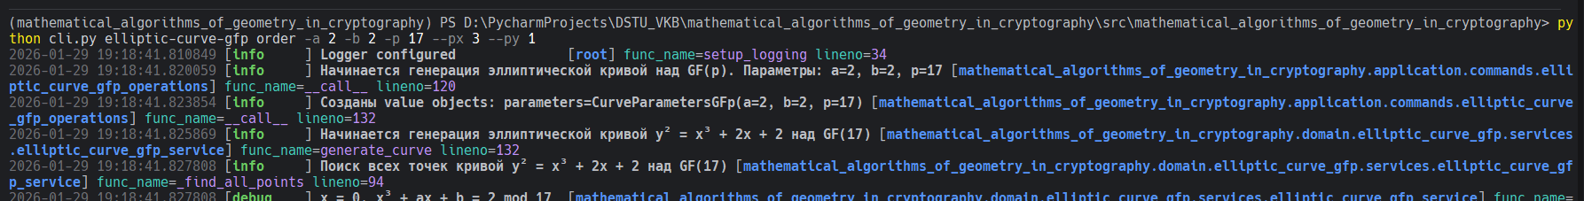
Рисунок 1 – команда для запуска лабораторной

В результате получилось такой результат, который представлен на рисунке 2.
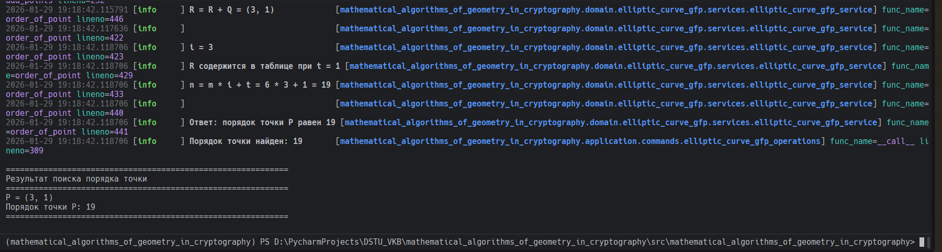
Рисунок 2 – результат запуска команды
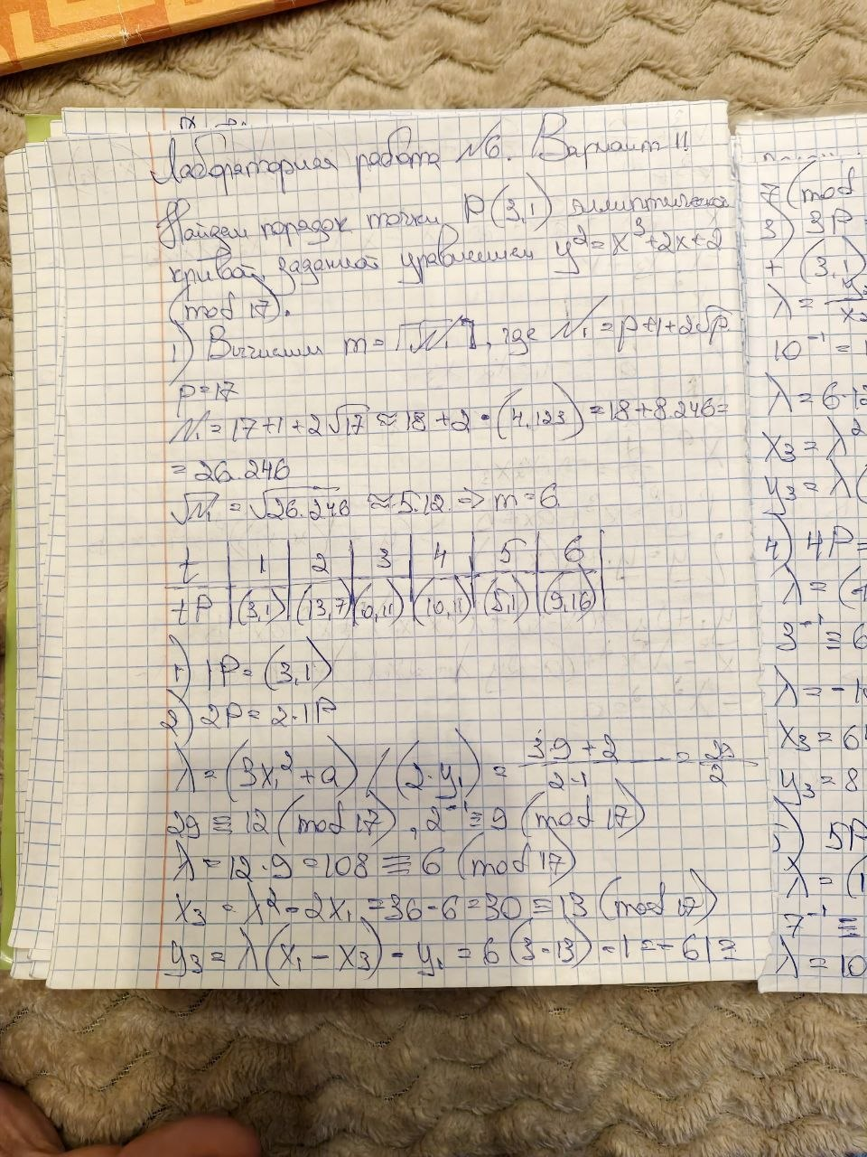
Рисунок 3 – Ручная отработка
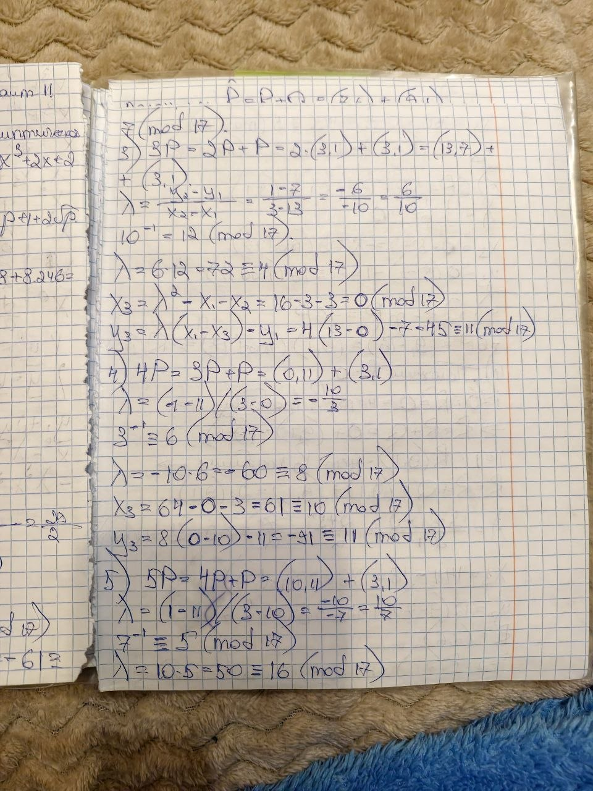
Рисунок 4 – Ручная отработка
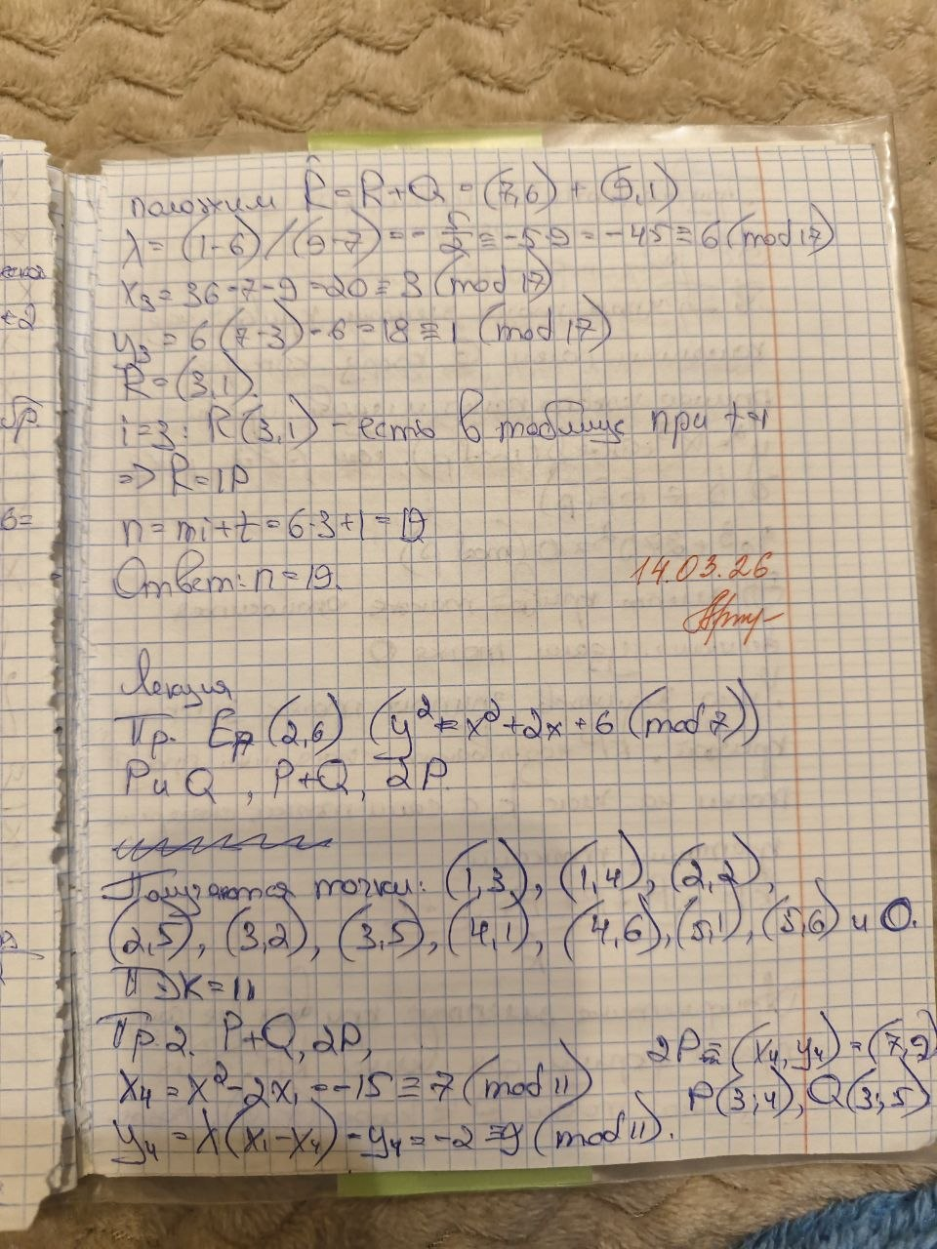
Рисунок 5 – Ручная отработка

Листинг

import logging
from typing import Final
from mathematical_algorithms_of_geometry_in_cryptography.domain.common.services.base import DomainService
from mathematical_algorithms_of_geometry_in_cryptography.domain.elliptic_curve_gfp.entities.elliptic_curve_gfp import (
EllipticCurveGFp,
)
from mathematical_algorithms_of_geometry_in_cryptography.domain.elliptic_curve_gfp.errors.elliptic_curve_gfp_errors import (
CurveGenerationError,
PointNotOnCurveError,
PointOperationError,
)
from mathematical_algorithms_of_geometry_in_cryptography.domain.elliptic_curve_gfp.ports.elliptic_curve_gfp_id_generator import (
EllipticCurveGFpIDGenerator,
)
from mathematical_algorithms_of_geometry_in_cryptography.domain.elliptic_curve_gfp.values.curve_parameters_gfp import (
CurveParametersGFp,
)
from mathematical_algorithms_of_geometry_in_cryptography.domain.elliptic_curve_gfp.values.gfp_point import (
GFpPoint,
)
logger: Final[logging.Logger] = logging.getLogger(__name__)
class EllipticCurveGFpService(DomainService):
"""
Domain service for working with elliptic curves over GF(p).
This service encapsulates the business logic for:
- Finding all points on the curve
- Adding points
- Doubling points
- Modular arithmetic operations
"""
def __init__(self, elliptic_curve_gfp_id_generator: EllipticCurveGFpIDGenerator) -> None:
super().__init__()
self._elliptic_curve_gfp_id_generator: Final[EllipticCurveGFpIDGenerator] = (
elliptic_curve_gfp_id_generator
)
@staticmethod
def _pow_mod(base: int, exp: int, mod: int) -> int:
"""
Compute base^exp mod mod using fast exponentiation.
Args:
base: Base number
exp: Exponent
mod: Modulus
Returns:
base^exp mod mod
"""
result = 1
base = base % mod
while exp > 0:
if exp % 2 == 1:
result = (result * base) % mod
exp = exp >> 1
base = (base * base) % mod
return result
@staticmethod
def _mod_inverse(a: int, p: int) -> int:
"""
Compute modular inverse of a modulo p using Fermat's little theorem.
Args:
a: Number to invert
p: Prime modulus
Returns:
a^(-1) mod p
"""
return EllipticCurveGFpService._pow_mod(a, p - 2, p)
def _find_all_points(self, parameters: CurveParametersGFp) -> list[GFpPoint]:
"""
Find all points on the elliptic curve y² = x³ + ax + b over GF(p).
Args:
parameters: Curve parameters
Returns:
List of all points on the curve (including infinity point)
"""
a = parameters.a
b = parameters.b
p = int(parameters.p)
points: list[GFpPoint] = []
logger.info("Поиск всех точек кривой y² = x³ + %sx + %s над GF(%s)", a, b, p)
for x in range(p):
# Calculate right-hand side: x³ + ax + b mod p
rhs = ((x ** 3) + a * x + b) % p
logger.debug("x = %s, x³ + ax + b = %s mod %s", x, rhs, p)
# Check all possible y values
for y in range(p):
y_squared = (y ** 2) % p
logger.debug(" y = %s, y² = %s mod %s", y, y_squared, p)
if y_squared == rhs:
point = GFpPoint(x=x, y=y)
points.append(point)
logger.debug(" Найдена точка: %s", point)
# Add infinity point
infinity_point = GFpPoint.infinity()
points.append(infinity_point)
logger.info("Найдено %s точек на кривой (включая точку бесконечности)", len(points))
return points
def generate_curve(self, parameters: CurveParametersGFp) -> EllipticCurveGFp:
"""
Generate an elliptic curve over GF(p) with given parameters.
Args:
parameters: Curve parameters (a, b, p)
Returns:
EllipticCurveGFp aggregate with all points
Raises:
CurveGenerationError: If curve generation fails
"""
try:
logger.info(
"Начинается генерация эллиптической кривой y² = x³ + %sx + %s над GF(%s)",
parameters.a,
parameters.b,
parameters.p,
)
# Find all points
points = self._find_all_points(parameters)
# Create aggregate
curve = EllipticCurveGFp(
id=self._elliptic_curve_gfp_id_generator(),
parameters=parameters,
points=points,
)
logger.info(
"Эллиптическая кривая успешно сгенерирована. "
"Порядок кривой: %s",
curve.order,
)
return curve
except Exception as e:
msg = f"Failed to generate elliptic curve: {e}"
logger.error(msg)
raise CurveGenerationError(msg) from e
def add_points(
self,
curve: EllipticCurveGFp,
p: GFpPoint,
q: GFpPoint,
) -> GFpPoint:
"""
Add two points P and Q on the elliptic curve.
Args:
curve: The elliptic curve
p: First point
q: Second point
Returns:
Result of P + Q
Raises:
PointNotOnCurveError: If points don't belong to the curve
PointOperationError: If point addition fails
"""
try:
p_value = int(curve.parameters.p)
a = curve.parameters.a
logger.info("Сложение точек: %s + %s", p, q)
# Check if points are on the curve
if not curve.contains_point(p):
msg = f"Point {p} does not belong to the curve"
raise PointNotOnCurveError(msg)
if not curve.contains_point(q):
msg = f"Point {q} does not belong to the curve"
raise PointNotOnCurveError(msg)
# Handle infinity point
if p.is_infinity:
logger.info("P - точка бесконечности, результат: %s", q)
return q
if q.is_infinity:
logger.info("Q - точка бесконечности, результат: %s", p)
return p
# Check if P + Q = O (points are inverses)
if p.x == q.x and (p.y + q.y) % p_value == 0:
logger.info("Точки являются обратными, результат: O")
return GFpPoint.infinity()
# Calculate lambda
if p == q:
# Point doubling: λ = (3x² + a) / (2y)
numerator = (3 * p.x * p.x + a) % p_value
denominator = self._mod_inverse(2 * p.y, p_value)
logger.info("Удвоение точки: числитель = %s, знаменатель = %s", numerator, denominator)
else:
# Point addition: λ = (y₂ - y₁) / (x₂ - x₁)
numerator = (q.y - p.y + p_value) % p_value
denominator = self._mod_inverse((q.x - p.x + p_value) % p_value, p_value)
logger.info("Сложение точек: числитель = %s, знаменатель = %s", numerator, denominator)
lambda_val = (numerator * denominator) % p_value
logger.info("λ = %s", lambda_val)
# Calculate result point
xr = (lambda_val * lambda_val - p.x - q.x) % p_value
yr = (lambda_val * (p.x - xr) - p.y) % p_value
result = GFpPoint(x=(xr + p_value) % p_value, y=(yr + p_value) % p_value)
logger.info("Результат: %s", result)
return result
except (PointNotOnCurveError, PointOperationError):
raise
except Exception as e:
msg = f"Failed to add points: {e}"
logger.error(msg)
raise PointOperationError(msg) from e
def double_point(
self,
curve: EllipticCurveGFp,
p: GFpPoint,
) -> GFpPoint:
"""
Double a point P on the elliptic curve (compute 2P).
Args:
curve: The elliptic curve
p: Point to double
Returns:
Result of 2P
Raises:
PointNotOnCurveError: If point doesn't belong to the curve
PointOperationError: If point doubling fails
"""
logger.info("Удвоение точки: 2 * %s", p)
return self.add_points(curve, p, p)
def multiply_point(
self,
curve: EllipticCurveGFp,
p: GFpPoint,
m: int,
) -> GFpPoint:
"""
Multiply a point P by a scalar m (compute mP) using dynamic programming.
Args:
curve: The elliptic curve
p: Point to multiply
m: Scalar multiplier
Returns:
Result of mP
Raises:
PointNotOnCurveError: If point doesn't belong to the curve
PointOperationError: If point multiplication fails
"""
try:
if m <= 0:
msg = f"Multiplier must be positive, got {m}"
raise ValueError(msg)
if m == 1:
logger.info("m = 1, результат: %s", p)
return p
# Check if point is on the curve
if not curve.contains_point(p):
msg = f"Point {p} does not belong to the curve"
raise PointNotOnCurveError(msg)
# Initialize array for dynamic programming
point_array: list[GFpPoint] = [p] * m
point_array[0] = p
logger.info("P = %s", point_array[0])
# Compute mP using dynamic programming
for i in range(2, m + 1):
logger.info("")
if i % 2 == 0:
# Even: iP = 2 * (i/2)P
half_index = i // 2 - 1
point_array[i - 1] = self.double_point(curve, point_array[half_index])
half_str = "" if i // 2 == 1 else f"{i // 2}"
logger.info(
"%sP = 2 * %sP = 2 * %s = %s",
i,
half_str if half_str else "",
point_array[half_index],
point_array[i - 1],
)
else:
# Odd: iP = (i/2)P + (i/2+1)P
half_index = i // 2 - 1
next_index = i // 2
point_array[i - 1] = self.add_points(
curve,
point_array[half_index],
point_array[next_index],
)
half_str = "" if i // 2 == 1 else f"{i // 2}"
logger.info(
"%sP = %sP + %sP = %s + %s = %s",
i,
half_str if half_str else "",
i // 2 + 1,
point_array[half_index],
point_array[next_index],
point_array[i - 1],
)
logger.info("")
logger.info("Ответ: %sP = %s", m, point_array[m - 1])
return point_array[m - 1]
except (PointNotOnCurveError, PointOperationError):
raise
except Exception as e:
msg = f"Failed to multiply point: {e}"
logger.error(msg)
raise PointOperationError(msg) from e
def order_of_point(
self,
curve: EllipticCurveGFp,
p: GFpPoint,
) -> int:
"""
Find the order of a point P on the elliptic curve using Baby-step Giant-step algorithm.
Args:
curve: The elliptic curve
p: Point to find order for
Returns:
Order of point P (smallest n such that nP = O)
Raises:
PointNotOnCurveError: If point doesn't belong to the curve
PointOperationError: If order calculation fails
"""
try:
import math
p_value = int(curve.parameters.p)
# Special case: order of infinity point is 1
if p.is_infinity:
logger.info("Точка бесконечности имеет порядок 1")
return 1
# Check if point is on the curve
if not curve.contains_point(p):
msg = f"Point {p} does not belong to the curve"
raise PointNotOnCurveError(msg)
# Calculate N1 = p + 1 + 2*sqrt(p)
n1 = p_value + 1 + 2 * math.sqrt(p_value)
m = math.ceil(math.sqrt(n1))
logger.info("N1 = %s", n1)
logger.info("m = %s", m)
# Build table: t -> tP for t = 1 to m
table: dict[GFpPoint, int] = {}
logger.info("")
logger.info("t Pt")
for t in range(1, m + 1):
pt = self.multiply_point(curve, p, t)
table[pt] = t
logger.info("%-3s %s", t, pt)
logger.info("")
# Calculate Q = mP, then -Q (inverse point)
q = self.multiply_point(curve, p, m)
# Inverse point: -Q = (Q.x, -Q.y mod p)
# Handle infinity point case
if q.is_infinity:
q_inverse = GFpPoint.infinity()
else:
q_inverse = GFpPoint(x=q.x, y=(-q.y + p_value) % p_value)
logger.info("")
logger.info("Q = %s", q_inverse)
# Initialize R = O (infinity point)
r = GFpPoint.infinity()
logger.info("R = %s", r)
# Baby-step Giant-step algorithm
for i in range(m):
logger.info("")
logger.info("i = %s", i)
# Check if R is in the table
if r in table:
t = table[r]
n = m * i + t
logger.info(
"R содержится в таблице при t = %s",
t,
)
logger.info(
"n = m * i + t = %s * %s + %s = %s",
m,
i,
t,
n,
)
logger.info("")
logger.info("Ответ: порядок точки P равен %s", n)
return n
# R = R + (-Q)
r = self.add_points(curve, r, q_inverse)
logger.info("R = R + Q = %s", r)
# Should not reach here if algorithm is correct
msg = "Failed to find point order"
logger.error(msg)
raise PointOperationError(msg)
except (PointNotOnCurveError, PointOperationError):
raise
except Exception as e:
msg = f"Failed to find point order: {e}"
logger.error(msg)
raise PointOperationError(msg) from e
def reverse_point(self, curve: EllipticCurveGFp, point: GFpPoint) -> GFpPoint:
"""
Get the inverse point -P = (x, -y mod p).
Args:
curve: The elliptic curve
point: Point to reverse
Returns:
Inverse point -P
"""
if point.is_infinity:
return GFpPoint.infinity()
p_value = int(curve.parameters.p)
return GFpPoint(x=point.x, y=(-point.y + p_value) % p_value)
def find_all_orders(self, curve: EllipticCurveGFp) -> dict[GFpPoint, int]:
"""
Find orders of all points on the elliptic curve.
Args:
curve: The elliptic curve
Returns:
Dictionary mapping points to their orders
"""
logger.info("Начинается поиск порядков всех точек кривой")
orders: dict[GFpPoint, int] = {}
for point in curve.points:
try:
order = self.order_of_point(curve, point)
orders[point] = order
logger.debug("Точка %s: порядок = %s", point, order)
except Exception as e:
logger.warning("Не удалось найти порядок точки %s: %s", point, e)
# Skip points that fail order calculation
continue
logger.info("Найдены порядки всех %s точек", len(orders))
return orders
def generate_sequence(
self,
curve: EllipticCurveGFp,
c: int,
x0: GFpPoint,
p: GFpPoint,
count: int,
is_congruent: bool,
) -> tuple[list[GFpPoint], int, str]:
"""
Generate pseudorandom sequence using congruent or inversive generator.
Congruent generator: X_i = c * X_{i-1} + P
Inversive generator: X_i = c * X_{i-1}^(-1) + P
Args:
curve: The elliptic curve
c: Multiplier coefficient
x0: Initial point X0
p: Point P
count: Number of iterations
is_congruent: True for congruent generator, False for inversive
Returns:
Tuple of (sequence, period, binary_sequence)
"""
try:
p_value = int(curve.parameters.p)
generator_type = "Конгруэнтный" if is_congruent else "Инверсивный"
logger.info(
"Начинается генерация последовательности (%s генератор). "
"c=%s, X0=%s, P=%s, итераций=%s",
generator_type,
c,
x0,
p,
count,
)
# Check if points are on the curve
if not curve.contains_point(x0):
msg = f"Point X0 {x0} does not belong to the curve"
raise PointNotOnCurveError(msg)
if not curve.contains_point(p):
msg = f"Point P {p} does not belong to the curve"
raise PointNotOnCurveError(msg)
# Initialize sequence
sequence: list[GFpPoint] = [x0]
binary_sequence = str(x0.y & 1 if not x0.is_infinity else 0)
period = 0
logger.info("X₀ = %s", x0)
# Generate sequence
for i in range(1, count):
# Compute c * X_{i-1} or c * X_{i-1}^(-1)
if is_congruent:
# Congruent: c * X_{i-1}
mp = self.multiply_point(curve, sequence[i - 1], c)
logger.info(
"X%s = %s * %s + %s = %s + %s",
self._subscript(i),
c,
sequence[i - 1],
p,
mp,
p,
)
else:
# Inversive: c * X_{i-1}^(-1)
reversed_point = self.reverse_point(curve, sequence[i - 1])
mp = self.multiply_point(curve, reversed_point, c)
logger.info(
"X%s = %s * %s^(-1) + %s = %s * %s + %s = %s + %s",
self._subscript(i),
c,
sequence[i - 1],
p,
c,
reversed_point,
p,
mp,
p,
)
# X_i = mp + P
next_point = self.add_points(curve, mp, p)
sequence.append(next_point)
# Add to binary sequence (least significant bit of y)
bit = next_point.y & 1 if not next_point.is_infinity else 0
binary_sequence += str(bit)
logger.info(" = %s", next_point)
# Period detection: period is the smallest k > 0 such that X_k == X_0
if period == 0 and next_point == x0:
period = i
logger.info("Период найден: %s (X%s = X₀)", period, self._subscript(i))
# If period not found in initial count, continue searching
if period == 0:
logger.info("Период не найден в первых %s итерациях, продолжаем поиск", count)
current = sequence[-1]
iteration = count
while True:
if is_congruent:
mp = self.multiply_point(curve, current, c)
else:
reversed_point = self.reverse_point(curve, current)
mp = self.multiply_point(curve, reversed_point, c)
current = self.add_points(curve, mp, p)
iteration += 1
# Period detection: period is the smallest k > 0 such that X_k == X_0
if current == x0:
period = iteration
logger.info("Период найден: %s (X%s = X₀)", period, self._subscript(iteration))
break
logger.info("Период: %s", period)
logger.info("Двоичная последовательность: %s", binary_sequence)
return sequence, period, binary_sequence
except (PointNotOnCurveError, PointOperationError):
raise
except Exception as e:
msg = f"Failed to generate sequence: {e}"
logger.error(msg)
raise PointOperationError(msg) from e
@staticmethod
def _subscript(number: int) -> str:
"""
Convert number to subscript string.
Args:
number: Number to convert
Returns:
String with subscript digits
"""
subscript_map = {
"0": "₀",
"1": "₁",
"2": "₂",
"3": "₃",
"4": "₄",
"5": "₅",
"6": "₆",
"7": "₇",
"8": "₈",
"9": "₉",
}
return "".join(subscript_map.get(d, d) for d in str(number))
Вывод: в ходе работы была реализована программа для определения порядка точки на эллиптической кривой над конечным полем. Программа позволяет вычислять порядок выбранной точки с использованием операций сложения и умножения точек.

